Kenya Vision 2013 and Youth Agenda
Background
Kenya Vision 2030 is the new country’s development blueprint covering the period 2008 to 2030 (NESC, 2009). It aims at making Kenya a newly industrializing, middle income country providing high quality life for all its citizens by the year 2030 (GoK, 2009). The Vision has been developed through an all-inclusive stakeholder consultative process, involving Kenyans from all parts of the country. The vision is based on three pillars namely: the economic pillar, the social pillar and the political pillar (NESC, 2009).

Figure1.1: An Overview of Kenya Vision 2030
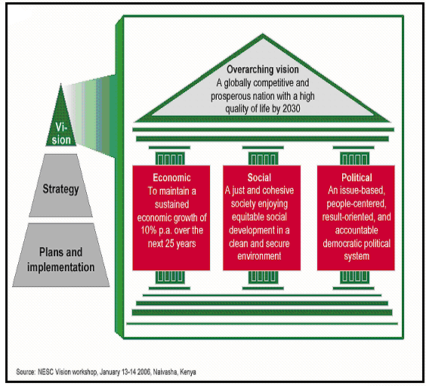

This vision’s programme plan comes after the successful implementation of the economic recovery Strategy for Wealth and Employment Creation.

The economic pillar aims at providing prosperity to all Kenyans through an economic development programme aimed at achieving an average Gross Domestic Product (GDP) growth rate of 10 % per annum the next 25 years (GoK, 2009). The social pillar seeks to build a just and cohesive society with social equity. The political pillar aims at realizing a democratic political system founded on issue-based politics that respects the rule of law, and protects the rights and freedoms of every individual in the Kenyan society (NESC, 2009).

According to World Bank (2008), Kenya Vision 2030 is to be implemented in successive five-year Medium Term plans with the first such plan covering the period 2008 – 2012. During the life of the Vision, strategies and action plans will be systematically reviewed and adjusted every 5 years in order to effectively respond to the changing global, regional and local environments. Thus, Vision 2030 will be delivered over many different horizons, each with defined goals and flagship projects. A detailed 5-year development plan (2008-2012) is has been prepared under the coordination of the Ministry of Planning and National Development. After 2011 another five-year plans will be produced covering the period 2012 to 2017, and so on till 2030 (GoK, 2009).

The first Vision 2030 horizon will focus on transforming Kenya’s current level of economic, social and political development between January 2008 and December 2012 as a first step towards achieving the Vision (NESC, 2009). To deliver on this ambitious process of national transformation will require a fundamental shift from multiple and often uncoordinated levels of decision making to centralized implementation process to a new management philosophy (from a limited sense of urgency to relentless follow up); legislation (from slow, reactive to fast, proactive legislating); special budgeting (from low and dispersed to high and ‘ring-fenced’ investments) as well as management of top talent (from shortage of skills to a war for talent) (GoK, 2009).

Youth Agenda as envisioned in Vision 2030
This study closely focuses on youth agenda as enshrined in the vision. The 2030 vision is expected to improve livelihoods of the youths and furthermore create a responsible, globally competitive and prosperous future for the youth in Kenya. The goal for 2012 is to increase opportunities such as employment and entrepreneurship among the youth in the society.

Youth have a critical role to play in the implementation of Vision 2030. It is very important for young people to take part in the monitoring of the implementation of the Vision 2030 flagship projects. This they can do through participation in the National Integrated Monitoring and Evaluation Strategy (NIMES) which will track the activities set out in the vision. These activities include mobilization of other young people to push for various reforms in the vision and in other institutional policy frameworks. This will create a critical mass to demand and facilitate accountability checks on the government on annual progress plans, budget and Medium Term Plans. Secondly, young people should optimize the opportunities that the Vision creates through business and participation in the implementing of flagship projects (NESC, 2009).

The youth should also participate in designing programmes for resource centers recommended by the Vision that would be beneficial to them. Additionally, they should innovatively develop business and productive proposals that would maximize on e-commerce, marketing, tourism, Business Process Outsourcing and modernized agricultural activities. They should also embrace pioneering Science, Technology and Innovation initiatives as economic ventures. Thirdly, the youth should use their innovativeness and creativity to suggest different ways of implementing the Vision and utilizing resources, such as harnessing wind power.

Fourthly, the youth should uphold the principles of constitutionalism, sovereignty of the people of Kenya, gender equality, national values, goals and ideology, rights, political party system, public participation in governance, separation of powers and centralization so as to provide a condusive environment for the achievement of the Vision 2030. The youths should also be actively engaged in political parties and change their attitude in political engagement by focusing on issue based politics and long term strategies as well as participate in social cohesion by building bridges across ethnic, regional and class divides. Participation in current national processes such as the constitutional review and the Truth Justice and Reconciliation will give the youth an opportunity to air their views on obstacles that hinder their progress and the attainment of the Vision 2030.

